Magistra Dicit:
  - Augustus XXVI-XXX

Quid novi? (What’s new?)
Salvete, omnes!  Welcome to the 2019-2020 school year! It’s been awesome to see the energy and enthusiasm people are bringing into the Latin classroom this year. I’m very excited to see how you all grow and learn this year. In this issue of Magistra Dicit, you can find an overview of what we’ll be studying this week, a ‘Help Wanted’ section, upcoming school events, and a variety of fun Latin easter eggs (that’s extra credit opportunities!).  Be safe, make good choices, et valete!  Magistra Ladd-Suits |  |  |  |  |  | Quid disces?  What are you learning?  Reading: Latin 1 is reading Stage 1 stories about Caecilius and the fam. Latin 2 is reading Stage 16 stories about how Quintus got to Britannia. Latin 3 is reading Stage 25 stories about Modestus and Strythio being absolute clowns. Latin 4 is breaking into letter format!  Writing: We will be writing about families and buildings.  Listening: We will have a listening quiz on Wednesday about some of the CLE terms.  Culture: Families, buildings, and soldiers, oh my!  Enuntio Hebdomadis:  Latin 1: salve!  Latin 2: quid est nomen tibi?  Latin 3: quid agis?  Latin 4: quomodo te habes?
Sententiam Latinam: aut viam inveniam aut faciam- “Either I will find a way or I will make one.” – Hannibal Barca, on crossing the Alps with war elephants

Help Wanted Upcoming Events:
Now accepting applicants for the following positions:  Calendarius- Someone to help read the dates in each class  Tessarius- Someone to listen for the Enuntio Hebdomadis (see ‘Quid Novi’ on page 1) and hand out raffle tickets |  | Aug 26, 27, 29, 31 – Home volleyball games  Aug 26 & 30- Home football game  Sept. 2- NO SCHOOL (Labor Day)
Raffle Ticket Opportunity!
Identify at least 1 deity in the picture below to Magistra for a ticket to enter in the weekly drawing!

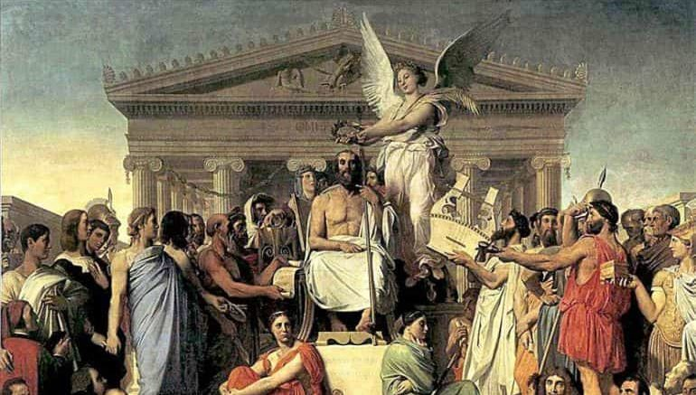
rch
Corner

